

**Industry Certifications**

**and**

**Articulation Agreements**

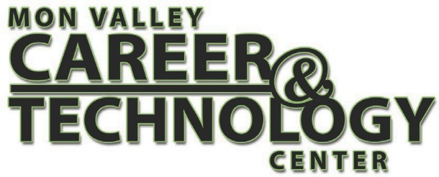

|  |
| --- |
| **Heating, Air Conditioning, Ventilation And Refrigeration Maintenance Technology/Technician 47.0201** |
|  |

|  |  |
| --- | --- |
| **Industry Certifications** | **Articulation Agreements** |
| * OSHA – 10 | * Thaddeus Stevens College of Technology - 10 credits |
| * EPA - 608 | * Community College of Allegheny County - 10 credits |
| * R-410A Technician | * Rosedale Technical College – 9.5 Credits |
| * NCCER – Various HVAC Certifications |  |
| * S/P2 – Construction |
| * S/P2 – Sustainability |
|  |